# LAB1 (Module 3) Machine Learning & AI World

# Google Has Developed A Self-Driving Car

* **If it is so important as the title says (is it really a big step?) or you think it is more important than the title let's suggests.**

**It is a big step indeed cause**

2.24 million injuries due to motor vehicle accidents in the United States in 2010, with [human error](http://www-nrd.nhtsa.dot.gov/Pubs/811059.PDF" \t "_blank) largely to blame. [Alcohol](http://www-nrd.nhtsa.dot.gov/Pubs/811552.pdf" \t "_blank), distracted driving (texting/eating/talking), and driver decision error (speeding/driving aggressively/misjudgment of road conditions) account for over 85% of all accidents.

A total of [35,332](http://www.cdc.gov/nchs/data/nvsr/nvsr61/nvsr61_04.pdf" \t "_blank) lives were lost that year due to motor vehicle accidents.

Google is hoping to make the streets a bit safer by [introducing a car that can drive by itself](http://googleblog.blogspot.com/2014/05/just-press-go-designing-self-driving.html" \t "_blank).

The [average American](http://www.usatoday.com/story/news/nation/2013/03/05/americans-commutes-not-getting-longer/1963409/" \t "_blank) has a commute of 25 minutes and about 8% of people spend over an hour in the car every day just to get to work.

* **Which part of ML or AI is used and how is it related to ML or AI.**

It is not said in the article but it is reinforced ML Learning based on AI (series of actions)

* **What did they do to take the data.**

On top of the car, a sensor spins around that actively monitors surroundings in all directions over 180 meters (0.1 mile) away. car’s computer gains information through both laser and radar sensors and will take camera data into account as well.

* **Which data did they use**

Google has actually been [utilizing driverless cars](http://www.popsci.com/cars/article/2013-09/google-self-driving-car" \t "_blank) for quite some time to collect data for Google Maps

* **How did they do to build the model. Which type of model is?**

Reinforced ML based on SARSA (State–action–reward–state–action )

The type of regression algorithms that can be used for self-driving cars are Bayesian regression, neural network regression and decision forest regression, among others.

Bayesian regression, neural network regression, and decision forest regressionare the three main types of regression algorithms used in self-driving cars. In regression analysis, the relationship between two or more variables is estimated, and the effects of the variables are compared on different scales

* **Do you know any other project that applies the same techniques? Could you use something for another use case?**

Amazon Scout self delivering robot https://www.youtube.com/watch?v=cdGabty6z-4

* **Do you find any ethical implications? Collateral effects?**
  + Threaten the jobs of taxi drivers, buses, limousines
  + Increase suburban sprawl, as many may be more willing to move away from the city and commute, if the commute would be shorter and less stressful.
  + Legal aspects to be sorted: While these cars do have the potential to make our lives considerably safer, the threat of an accident will always be present. A pedestrian could easily step off the curb in front of the car, which may not have enough time to stop. There is not a clear-cut answer of who would be at fault in that scenario.
  + Data privacy: The cars would likely track data regarding crashes, but how much else would it store? Insurance companies that would require data related to the crash may have access to unrelated, private information.
* **Do you know any news related?**

Yes, Tesla has been working on integrating such feature to their cars and current models are using semi-automated driving approach. Recently, the taxi company in France G7 put their 30 Tesla cars on hold before having answers on how safe the car is after one driver lost control of his car and hit many cars and injured people in Paris last November

**Article**

* There were 2.24 million injuries due to motor vehicle accidents in the United States in 2010, with [human error](http://www-nrd.nhtsa.dot.gov/Pubs/811059.PDF) largely to blame. [Alcohol](http://www-nrd.nhtsa.dot.gov/Pubs/811552.pdf), distracted driving (texting/eating/talking), and driver decision error (speeding/driving aggressively/misjudgment of road conditions) account for over 85% of all accidents. A total of [35,332](http://www.cdc.gov/nchs/data/nvsr/nvsr61/nvsr61_04.pdf) lives were lost that year due to motor vehicle accidents, which is more than triple the amount of people lost to homicide involving a firearm. Google is hoping to make the streets a bit safer by [introducing a car that can drive by itself](http://googleblog.blogspot.com/2014/05/just-press-go-designing-self-driving.html). Initially, 100 prototype subcompact vehicles will be released and they could be ready to hit the road in less than a year.
* The vehicle looks very similar to two-passenger subcompact “smart cars” currently on the market, but there are some distinct noticeable differences: **no steering wheel** or **pedals to accelerate/decelerate**. Human drivers actually play a very small role in operating the vehicle. To operate the car, the passenger merely presses a button to start the car and then inputs the destination into the car’s computer that utilizes Google Maps. The car does the rest. However, there is an emergency break available, to be used if necessary.
* 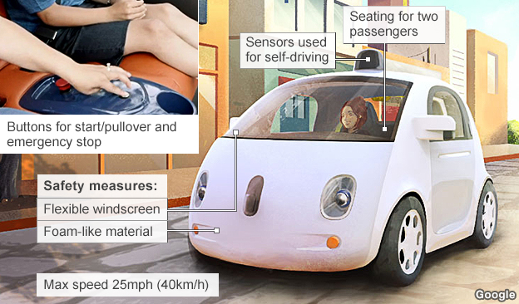
* On top of the car, a sensor spins around that actively monitors surroundings in all directions over 180 meters (0.1 mile) away. The **car’s computer gains information through both laser and radar sensors and will take camera data into account as well**. This feature eliminates blind spots, making intersections and changing lanes in traffic much safer.
* 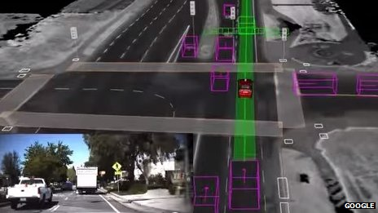
* The first cars manufactured by Google will not be commercially available, but will be used purely for research purposes. The car currently tops out at 40 km/h (25 mph) as a safety measure. The vehicles also don’t have many comfort features to speak of, unless you count seat belts and leg room as “features” (I don’t). However, the less time Google spends installing cup holders and Bluetooth connectivity, the more time they will have to study how the car operates in a real setting and can move on to applying it to larger, more practical cars.
* The electric car has a foam-like material for the body and uses a flexible, plastic windshield. The body of the front of the car has been molded to resemble a cartoony face, which we can only hope is temporary during this learning phase and will not be on those vehicles eventually put on the market.
* Imagine how a morning commute would change if there was extra time to read or eat in the car on the way to work and how much faster the ride would be without preventable accidents causing congestion? The [average American](http://www.usatoday.com/story/news/nation/2013/03/05/americans-commutes-not-getting-longer/1963409/) has a commute of **25 minutes and about 8% of people spend over an hour in the car every day just to get to work.** Even on the lower end, a driverless car could provide over 200 hours of personal time in a year that could be spent reading books instead of staring at tail lights.
* Self-driving cars could also be beneficial to those who cannot drive regular cars due to advanced age, vision impairments, or certain medical conditions. Depending on what happens with regulations, it could also be used by someone under the age of 16.
* Google has actually been [utilizing driverless cars](http://www.popsci.com/cars/article/2013-09/google-self-driving-car) for quite some time to collect data for Google Maps, though those vehicles have been modified pre-existing cars with a driver in the front seat just in case. The first vehicles manufactured by Google will also feature a safety driver initially as well. Over the next few years, they hope to introduce a small number of vehicles the way they are intended to be run in California, and then expanding operations if and when it is appropriate to do so.
* Of course, there are concerns when looking at a future of self-driving cars. It may threaten the jobs of those who drive taxis/buses/limousines and increase suburban sprawl, as many may be more willing to move away from the city and commute, if the commute would be shorter and less stressful. Additionally, there are some **legal aspects to be sorted**. While these cars do have the potential to make our lives considerably safer, the threat of an accident will always be present. A pedestrian could easily step off the curb in front of the car, which may not have enough time to stop. There is not a clear-cut answer of who would be at fault in that scenario. Additionally, the cars would likely track data regarding crashes, but how much else would it store? Insurance companies that would require data related to the crash may have access to unrelated, private information.